**Sprint 2 Plan, Detective Dollar**

Detective Dollar Team. Completion by Monday 10/23/23

**Goal:** Creating spending graphs and allowing the user to better manage their inputted expenses.

**Task Listing:**

User Story 1: As a user, I should be able to view a pie chart of my expenses

1. Create a backend function to get expenses by category (< 2 hours)
2. Create a backend function to get expenses by time frame (< 2 hours)
3. Create a page within the app (< 30 mins)
4. Get data from the backend and create a Pie chart (< 1 hour )

Total for User Story: 3.75 hours

User Story 2: As a user, I can see a navigation bar at the bottom to switch between daily expenses, graphs, and entering expenses

1. Create Nav bar icons (< 30 mins)
2. Create Nav bar component (<40 mins)
3. Add a nav bar to each page (< 10 mins)

Total for User Story: 1.20 hours

User Story 3: As a user, I can delete an expense

1. Create backend functionality to delete entries from CSV (< 2 hour)
2. Add delete option on the home screen (< 30 mins)
3. Create a popup for confirming action (< 30 mins)

Total for User Story: 3 hours

User Story 4: As a user, I can mark expresses as recurring

1. Add recurring option to Add expenses page (< 30 min)
2. Design new CSV to store recurring expenses (< 30 min)
3. Create functions to add to the new CSV (< 3 hour)
4. Add an icon to the home page to see that the expense is recurring (< 30 mins)

Total for User Story: 4.30 hours

**Team Roles:**

Thomas: Developer

Hersh: Scrum Master /Developer

Rohan: Developer

Ben: Developer

Cecile: Graphic Designer / Developer

**Initial Task Assignment:**

Thomas ➡ User Story: 1 Task: 3, 4 ;

Hersh ➡ User Story: 1 Task: 2;

Non-user story task: Learn Unit testing for React Native apps, and learn how to have GitHub automate them

Rohan ➡ User Story: 2 Task: 1- 3

Ben ➡ User Story: Task: 1 - 3

Cecile ➡ User Story: 1 Task: 1, User Story 2 Task 1- 4

**Initial Burnup Chart:**

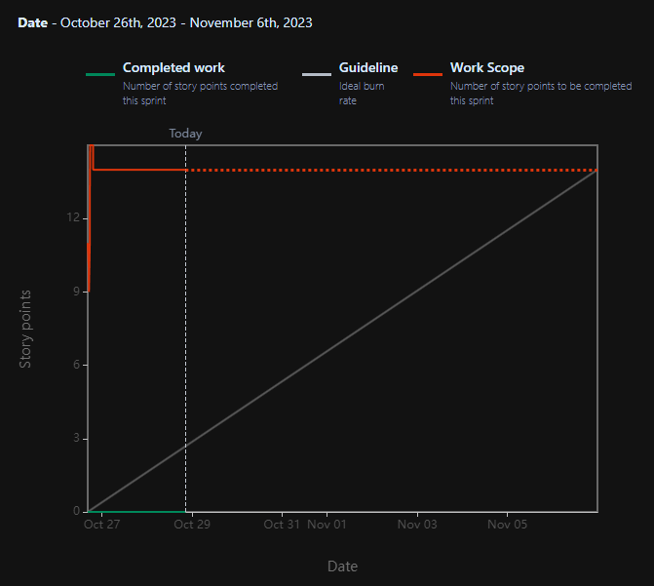

**Initial Scrum Board:**

| **USER STORIES** | **TODO** | **IN PROGRESS** | **COMPLETE** |
| --- | --- | --- | --- |
| As a user, I can input an expense frequency for recurring expenses | Add recurring option to Add expenses page  Design a new CSV to store recurring expenses  Create functions to add to the new CSV  Add an icon to the home page to see that the expense is recurring |  |  |
| As a user, I can delete expenses I no longer need | Create backend functionality to delete entries from CSV  Add a delete option on the home screen  Create a popup for confirming action |  |  |
| As a user, I can see a navigation bar at the bottom to switch between daily expenses, graphs, and entering expenses | Add a nav bar to each page | Create Nav bar icons  Create a Nav bar component |  |
| As a user, I should be able to view a pie chart of my expenses | Create a backend function to get expenses by category  Create a backend function to get expenses by time frame  Create a page within the app  Get data from the backend and create a Pie chart |  |  |

**Scrum Times:**

Mondays: 10am - 10:45 with TA

Thursdays: 4:15 pm - 5:15 pm

Sundays: 6 pm - 7 pm